Online Bookstore System

*Project Report Submitted By*

# Narayanan M

# Reg.No: ZTAVMVS011

*In Partial fulfillment for the Award of the Degree Of*

**MASTER OF VOCATION IN SOFTWARE DEVELOPMENT**

# (With Specialization in Data Analytic)

**CALICUT UNIVERSITY**



**CENTER FOR COMPUTER SCIENCE AND INFORMATION**

**TECHNOLOGY PERAMANGALAM**

# 2021-2023

**UNIVERSITY OF CALICUT**

**CENTRE FOR COMPUTER SCIENCE AND INFORMATION TECHNOLOGY PERAMANGALAM, THRISSUR**

**MASTER OF VOCATION IN SOFTWARE DEVELOPMENT (DATA ANALYTICS)**



**CERTIFICATE**

This is to certify that the Project report, “**Online Bookstore System”** is the work of **Narayanan M (Reg.No:** **ZTAVMVS011)** in partial fulfillment of the requirements for the award of the Degree of Master of Vocation in Software Development specialized with Data Analytic under Calicut University during the year 2022-23.

|  |  |
| --- | --- |
| **Internal Guide** | **Ms. Veena Vijayan**  **Coordinator** |
|  |  |

**Head of the Department External Examiner**

## ACKNOWLEDGEMENT

First and foremost, I thank God almighty for his eternal love and protection throughout the project. I take this opportunity to express my gratitude to all who helped me in completing this project successfully. It has been said that gratitude is the memory of the heart. I wish to express my sincere gratitude to our Assistant Coordinator **Ms.Fathimath Raziya K** for providing good faculty for guidance.

I extend my whole hearted thanks to the Project Coordinator **Ms Sreelekha C K** for their valuable suggestions and for overwhelming concern and guidance from the beginning to the end of the project. I would also like to express sincere gratitude to my Project Guide**, Ms Sreelekha C K** for her inspiration and helping hand.

I thank our dearest educators for their participation and ideas that helped me all through the task. I express my gratitude to every one of my companions and colleagues for their advantage, devotion, and consolation displayed towards the task. I pass my generous thanks on to my family for the ethical help, ideas, and support to make this adventure a triumph.

Narayanan.M

**DECLARATION**

I hereby declare that the project report **“Online Bookstore System”** is a bonafided work done at CCSIT peramangalam, towards the partial fulfillment of the requirements for the award of the Degree of Master of Vocation in Software Development (MVoc) from Calicut University, during the academic year 2021-2023.

**Date: 25/07/2022 Narayanan M**

**PERAMANGALAM Reg. No: ZTAVMV011**

**ABSTRACT**

* The Online Bookstore Project in Django is an e-commerce website designed for book enthusiasts to purchase and search for books online. The system provides a user-friendly interface for customers to browse, search, and order books based on category, author, and subject. The project includes various features for both the admin and customer. For the admin, the dashboard provides a summary of products, orders, and categories. The admin has the capability to manage books by adding, updating, and deleting them from the system. The admin can also manage categories, orders, and user accounts. The website has a secure login and logout system to ensure privacy and security. For customers, the login page enables them to access their accounts, and the home page displays the books available for sale. Customers can view specific book information on the book view page and add them to their cart. The cart list page displays the items the customer has chosen, and they can complete the checkout process. The project includes a payment method that uses Paypal and credit card payments. The Online Bookstore project is a great academic project for final-year students to gain hands-on experience in developing a Django-based e-commerce website.

**CONTENT**

|  |  |  |
| --- | --- | --- |
| **Sl. No** | **Topic** | **Page No** |
| **1** | **INTRODUCTION** | **1** |
| **1.1** | **PROJECT OVERVIEW** | **2** |
| **1.2** | **PROJECT SPECIFICATION** | **2** |
| **2** | **SYSTEM STUDY** | **4** |
| **2.1** | **INTRODUCTION** | **5** |
| **2.2** | **EXISTING SYSTEM** | **6** |
| **2.3** | **DRAWBACKS OF EXISTING SYSTEM** | **6** |
| **2.4** | **PROPOSED SYSTEM** | **6** |
| **2.5** | **ADVANTAGES OF PROPOSED SYSTEM** | **7** |
| **3** | **REQUIREMENT ANALYSIS** | **8** |
| **3.1** | **FEASIBILITY STUDY** | **9** |
| **3.1.1** | **ECONOMICAL FEASIBILITY** | **9** |
| **3.1.2** | **TECHNICAL FEASIBILITY** | **10** |
| **3.1.3** | **BEHAVIORAL FEASIBILITY** | **10** |
| **3.2** | **SYSTEM SPECIFICATION** | **11** |
| **3.2.1** | **HARDWARE SPECIFICATION** | **11** |
| **3.2.2** | **SOFTWARE SPECIFICATION** | **11** |
| **3.3** | **SOFTWARE DESCRIPTION** | **11** |
| **3.3.1** | **PYTHON** | **11** |
| **3.3.2** | **MYSQL** | **12** |
| **4** | **SYSTEM DESIGN** | **14** |
| **4.1** | **INTRODUCTION** | **15** |
| **4.2** | **DATA FLOW DIAGRAM** | **15** |
| **4.3** | **DATA BASE DESIGN** | **17** |

|  |  |  |
| --- | --- | --- |
| **5** | **SYSTEM TESTING** | **26** |
| **5.1** | **INTRODUCTION** | **27** |
| **5.2** | **TEST PLAN** | **28** |
| **5.2.1** | **UNIT TESTING** | **28** |
| **5.2.2** | **INTEGRATION TESTING** | **29** |
| **5.2.3** | **WIDGET TESTING** | **29** |
| **5.2.4** | **SELENIUM TESTING** | **30** |
| **6** | **CONCLUSION & FUTURE SCOPE** | **31** |
| **6.1** | **CONCLUSION** | **32** |
| **6.2** | **FUTURE SCOPE** | **32** |
| **7** | **BIBLIOGRAPHY** | **33** |
| **8** | **APPENDIX** | **35** |
| **8.1** | **SCREEN SHOTS** | **36** |

# INTRODUCTION

##### PROJECT OVERVIEW

"Bookshala" is online Book Store Project in Django is an e-commerce web application that enables customers to search, browse, and purchase books online. The project has been built using the Django framework and utilizes the SQLITE3 database. . Bookshala is a web application which is valuable for readers to select their desired book . The system includes features for both the admin and customers, such as managing books, categories, orders, and users, and a secure login and logout system.

##### PROJECT SPECIFICATIONS

The purpose of the Online Bookstore System is to provide a convenient and efficient e-commerce platform for customers to purchase books online. The system allows customers to search and browse through a wide variety of books, organized by category, author, and subject. By providing an online bookstore, the system eliminates the need for customers to physically visit a bookstore, thus saving time and effort. Bookshala front end is carried out by utilizing HTML, CSS, JavaScript and back end utilizing Python Django framework and MySQL.

The system includes 3 modules. They are:

##### Admin Module

The Admin feature of the Online Book Store project includes a dashboard that allows the admin to have access to the entire system, including a summary of products, orders, and categories. The admin can manage the books by adding, updating, and deleting them. The Manage Categories page allows the admin to add, edit, and delete category information. The admin can also manage customer orders by accepting or rejecting them on a case-by-case basis, with a list of customer orders available. The admin can manage user accounts by adding, updating, or blocking users in the system. The system also features a secure login and logout system for added security.

##### Customer Module

The Customer feature of the Online Book Store project includes a Login Page where customers enter their website credentials to log in. The Register Page is where new customers can create their login credentials for the website. Students can progress their growth based on their daily work. The Home Page serves as the system's default page for customers, displaying the books for sale in the store or allowing them to search for specific keywords.The Book View Page shows the specific information about a product and allows the customer to add it to their cart.The Cart List Page lists the items the customer has chosen, and serves as the page for completing the order checkout process. The My Order Page displays the customer's order history. The system also supports PayPal and Credit Card Payments as a payment method.

##### Writer Module

Writer mail his or her work to admin mail provided at footer of the site. The admin check the work and add it to the site.

# SYSTEM STUDY

##### INTRODUCTION

System analysis is the process of acquiring and analyzing data, diagnosing issues, and using the data to suggest system changes. The system users and system developers must communicate extensively during this problem-solving process. Any framework improvement cycle ought to begin with a framework investigation or exploration. The framework is carefully inspected and surveyed. The framework investigator accepts the job of a questioner and digs profoundly into how the ongoing framework capabilities. The contribution to the framework is recognized, and the framework is viewed all in all. The different strategies can be connected to the results from the associations. Monitoring the issue, tracking down the relevant and significant factors, investigating, and orchestrating are portions of framework examination.

The interaction should be entirely concentrated on utilizing various philosophies, including surveys and meetings. To arrive at a resolution, the data assembled by these sources should be painstakingly inspected. Understanding how the framework functions is the end. The ongoing framework is the name of this framework. Presently, the ongoing framework is painstakingly analyzed, and issue regions are found. The creator presently goes about as an issue solver and attempts to determine the issues the business is having. Proposition are made instead of the arrangements. The proposition is then logically contrasted with the ongoing framework, and the best one is picked. The client is offered the chance to endorse or dismiss the idea. The proposition is inspected for suitable changes in view of client demands.

The process of acquiring and analyzing data in order to use it for future system studies is known as preliminary study. Initial research is a problem-solving activity that necessitates close coordination between system users and developers. It conducts a number of feasibility studies. These investigations provide an approximate estimate of the system activities, which can be used to determine the tactics to be used for an efficient system research and analysis.

##### EXISTING SYSTEM

* The existing system of offline bookstores faces several challenges, including a limited reach as they can only sell to customers in their immediate area, high overhead costs such as rent, utilities, and staffing that make it difficult to stay profitable, difficulty in managing inventory manually which can be time-consuming and prone to errors, limited hours of operation that may not suit customers with busy schedules, limited selection of books due to physical space constraints, and limited marketing options that rely mainly on foot traffic and word-of-mouth.

##### DRAWBACKS OF EXISTING SYSTEM

* High overhead costs.
* limited hours of operation.
* limited selection of books paper.
* limited marketing options.

##### PROPOSED SYSTEM

* The proposed system is an online bookstore system developed using Django framework. It aims to address the limitations of the existing offline bookstores by providing a wider reach, lower overhead costs, easier inventory management, 24/7 operation, and a larger selection of books.With the online bookstore system, customers can browse and purchase books from anywhere at any time, and the system will automatically update the inventory levels.The payment system will allow customers to securely pay with PayPal or credit card, making the checkout process smooth and hassle-free

##### ADVANTAGES OF PROPOSED SYSTEM

The system is very simple in design and to implement. The system requires very low system resources and the system will work in almost all configurations. It has got following features:

* Increased reach
* Lower overhead costs
* Efficient inventory management
* 24/7 availability
* Expanded selection
* Robust marketing capabilities

# 

# REQUIREMENT ANALYSIS

## FEASIBILITY STUDY

A plausibility study is led to decide if the task will, upon finishing, satisfy the targets of the association comparable to the work, exertion, and time put resources into it. A practicality study empowers the engineer to foresee the venture's helpfulness and expected future. A framework proposition's functionality, which remembers the impact for the association, ability to fulfill client needs, and productive utilization of assets, is the reason for a possibility study. Thus, before another application is acknowledged for improvement, it frequently goes through a practicality evaluation.

The record frames the undertaking's reason ability and contains various variables that were painstakingly considered all through this venture's attainability study, including its specialized, financial, and functional viabilities. It has the accompanying attributes: -

##### Economical Feasibility

Cost and benefit analyses are required to support the emerging system. criteria to make sure that focus is placed on the project that will yield the best results the earliest. The price that would be involved in developing a new system is one of the variables.

Some significant financial queries raised during the initial probe include the following:

* The costs direct a full framework examination.
* The expense of the equipment and programming.
* The advantages as diminished costs or less expensive mistakes.

The proposed system was created as part of a project; hence, there are no manual expenses associated with it. Additionally, the fact that all of the resources are already at hand indicates that the system may be developed affordably.

The expense of venture, ‘Bookshala’ was partitioned by the framework utilized, its advancement endlessly cost for facilitating the task. As per everything the computations the venture was created in a minimal expense. As it is totally evolved utilizing open source programming.

##### Technical Feasibility

The system needs to be assessed first from a technical standpoint. An overview design of the system's requirements in terms of input, output, programs, and procedures must serve as the foundation for the assessment of this viability. The inquiry must next advise the kind of equipment, necessary procedure for constructing the system, and means of operating the system once it has been designed after having identified an outline system.

Technical issues raised during the investigation are:

* Does the existing technology sufficient for the suggested one?
* Can the system expand if developed?

The project should be developed such that the necessary functions and performance are achieved within the constraints. The project requires High Resolution Scanning device and utilizes Cartographic techniques. Through the technology may become obsolete after some period of time, due to the fact that newer version of same software supports older versions, the system may still be used. So there are minimal constraints involved with this project. The system has been developed using PYTHON in front end and MySQL in server in back end, the project is technically feasible for development. The System used was also of good performance of Processor Intel i3 core; RAM 4GB and, Hard disk 1TB

##### Behavioral Feasibility

The proposed system includes the following questions:

* Is there sufficient support for the users?
* Will the proposed system cause harm?

The project would be advantageous because, when created and implemented, it would achieve the goals. The project is deemed to be behaviorally feasible after carefully weighing all behavioral factors.

## SYSTEM SPECIFICATION

##### Hardware Specification

Processor - Intel core i3

RAM - 2 GB

Hard disk - 256GB

##### Software Specification

Front End - HTML, CSS

Back-end - MySQL Client on PC - Windows.

Technologies used - JS, HTML, J Query, Python, CSS, Django

## SOFTWARE DESCRIPTION

##### Python

Python is an interpreted, object-oriented, high-level, dynamically semantic programming language. It is particularly appealing for Rapid Application Development as well as for usage as a scripting or glue language to tie existing components together due to its high- level built-in data structures, dynamic typing, and dynamic binding. Python's straightforward syntax priorities readability and makes it simple to learn, which lowers the cost of programme maintenance. Python's support for modules and packages promotes the modularity and reuse of code in programs. For all popular platforms, the Python interpreter and the comprehensive standard library are freely distribute and available in source or binary form.

A Python-based web framework called Django enables you to easily build effective online apps. Django is characterized as a &quot;batteries-included&quot; framework since it provides the built-in capability for everything, including the Django Admin Interface

and the default database, SQLlite3. Django is the simplest Framework to comprehend, has rapid development, and fully integrated Batteries.

##### MySQL

MySQL, the most popular Open Source SQL database management system, is developed, distributed, and supported by Oracle Corporation. The MySQL Web site provides the latest information about MySQL software.

##### MySQL is a database management system.

A systematic collection of data is called a database. It might be anything, such as a straightforward grocery list, a photo gallery, or the enormous amount of data in a business network. A database management system like MySQL Server is required in order to add, access, and process data that is stored in a computer database. Database management systems, whether used as stand-alone programmes or as a component of other applications, are essential to computing because computers are excellent at processing vast volumes of data.

##### MySQL databases are relational.

Instead of placing all the data in one huge warehouse, a relational database keeps the data in individual tables. Physical files that are designed for speed contain the database structures. The logical model provides a flexible programming environment with objects like databases, tables, views, rows, and columns. One-to- one, one-to-many, unique, compulsory or optional, and "pointers" between distinct tables are a few examples of the rules you might build up to regulate the relationships between various data fields. With a well-designed database, your application won't ever encounter inconsistent, duplicate, orphan, out-of-date, or missing data since the database enforces these rules. MySQL stands for "Structured Query Language" with the SQL prefix. The most popular standard language for accessing databases is SQL. Depending on the context in which you're writing, you might immediately enter Embed SQL statements into code written in another language (for instance, to generate reports), or use a language-specific API that obscures the SQL syntax. By way of the ANSI/ISO SQL Standard, SQL is defined. Since its inception in 1986, the SQL standard has undergone multiple revisions. In this document, "SQL92" refers to the 1992 standard, "SQL: 1999" to the 1999 standard, and "SQL: 2003" to the most recent version of the standard. The SQL Standard as it exists at any one time is referred to as "the SQL standard."

##### MySQL software is Open Source*.*

Anyone can use and modify the software because it is open source. The MySQL software is available for free download and usage online by anyone. You are free to examine the source code and modify it as necessary. The GPL (GNU General Public License) is used by the MySQL software to specify what you are allowed to do and are not allowed to do with the software in certain circumstances. You can purchase a commercially licensed version from us if the GPL makes you uncomfortable or if you need to integrate MySQL code into a for-profit application. For further details, see the MySQL Licensing Overview.

* **The MySQL Database Server is very fast, reliable, salable, and easy to use.** You ought to give it a shot if that is what you're after. In addition to your other apps, web servers, and other software, MySQL Server can function smoothly on a desktop or laptop while requiring little to no maintenance. You can modify the settings to utilize all the RAM, CPU power, and I/O capacity if you dedicate an entire machine to MySQL.

##### MySQL Server works in client/server or embedded systems*.*

The MySQL Database Software is a client/server system that includes a multi- threaded SQL server that supports several client programs and libraries, administration tools, and a broad variety of application programming interfaces (API’s). Additionally, we provide MySQL Server as an integrated multi-threaded library that you can link into your programme to create a standalone offering that is smaller, faster, and simpler to operate.

# 

# SYSTEM DESIGN

* 1. **INTRODUCTION**

Design is the first step into the development phase for any engineered product or system. Design is a creative process. A good design is the key to effective system. The term “design” is defined as “the process of applying various techniques and principles for the purpose of defining a process or a system in sufficient detail to permit its physical realization”. One way to describe it is as the process of using different methodologies and concepts to specify a device, a process, or a system in enough detail to allow for its physical reality. Regardless of the development paradigm that is employed, software design forms the technical core of the software engineering process. The architectural detail needed to construct a system or product is developed through the system design. This programme has also through the best possible design phase, fine tuning all efficiency, performance, and accuracy levels, as in the case of any systematic technique. A user-oriented document is converted into a document for programmers or database staff throughout the design phase. There are two stages to the development of a system design: Logical and Physical design.

## 4.2 DATA FLOW DIAGRAM

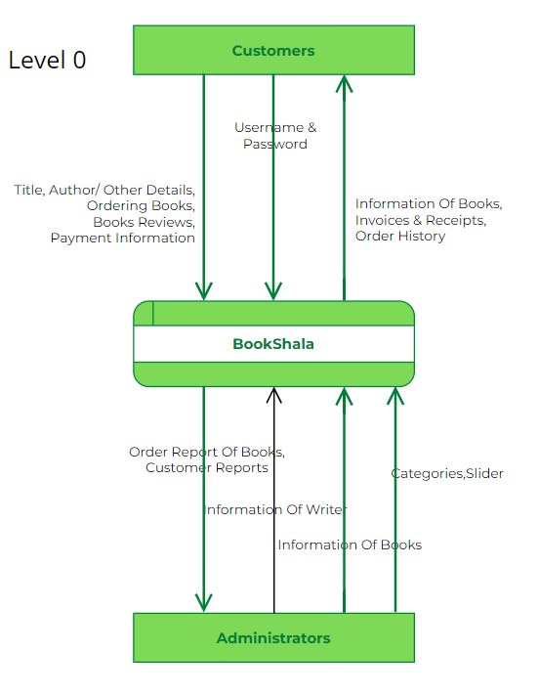

## 1.Admin

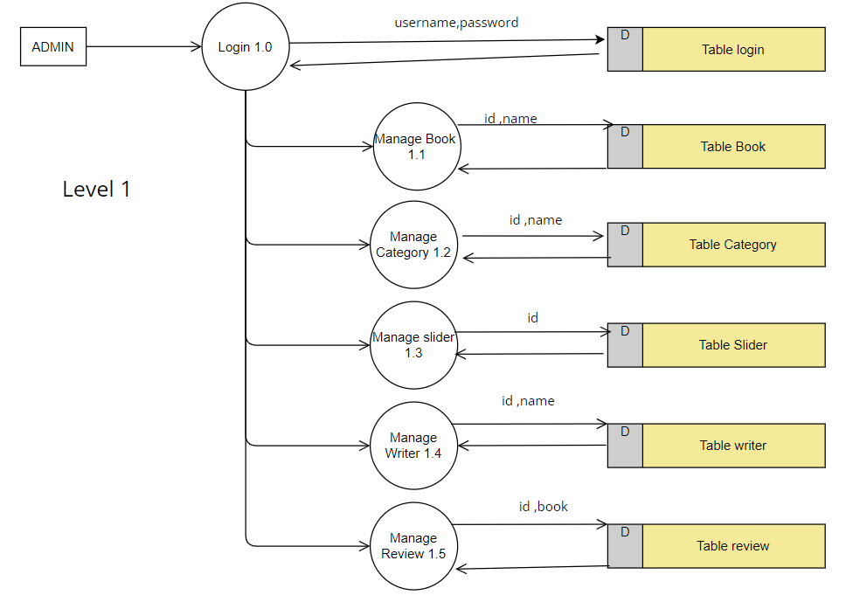

## 2.Customer

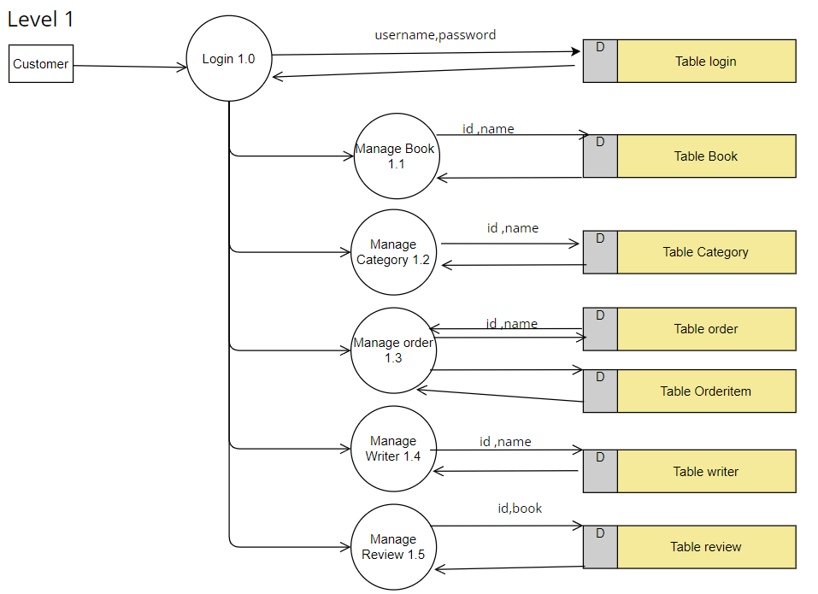

**4.3 DATA BASE DESIGN**

The aim of the diagram is explained by the word "deployment" itself. For depicting the physical components where software components are delivered, deployment diagrams are employed. Deployment diagrams and component diagrams have a lot in common. Diagrams of the components are used to describe them, and diagrams of their deployment in hardware are shown.

UML is primarily made to concentrate on a system's software artefacts. These two diagrams, however, are unique ones that highlight the hardware and software components.

Deployment diagrams are meant to concentrate on the hardware topology of a system, whereas most UML diagrams are used to handle logical components. The system engineers make use of deployment diagrams the particular DBMS that will be employed. Parallel to the system design is a database design. The database's data arrangement aims to accomplish the two main goals listed below.

* Data Integrity
* Data independence

##### Relational Database Management System (RDBMS)

In a relational model, the database is shown as a set of relations. Each relation resembles a file or table of records with values. A row is referred to as a tuple, a column heading is referred to as an attribute, and the table is referred to as a relation in formal relational model language. A relational database is made up of a number of tables, each with its own name. In a story, a row corresponds to a group of connected values.

##### Relations, Domains & Attributes

A relation is a table. Tuples are the units of a table's rows. An ordered group of n elements is a tuple. Attributes are referred to as columns. Every table in the database has relationships already established between them. This guarantees the integrity of both referential and entity relationships. A group of atomic values make up a domain D. Choosing a data type from which the domain's data values are derived is a typical way to define a domain. To make it easier to understand the values of the domain, it is also helpful to give it a name.

Each value in a relation is atomic and cannot be broken down.

##### Relationships

* Key is used to create table relationships. Primary Key and Foreign Key are the two principal keys that are most crucial. With the use of these keys, relationships for entity integrity and referential integrity can be created.
* Entity Integrity forbids the use of null values for any Primary Key.
* No Primary Key may have null values, according to the principle of referential integrity.
* Referential Integrity: A Primary Key value in the same domain must correspond to each unique Foreign Key value. Super Key and Candidate Keys are additional keys.

##### Normalization

The simplest possible grouping of data is used to put them together so that future changes can be made with little influence on the data structures. The formal process of normalizing data structures in a way that reduces duplication and fosters integrity. Using the normalization technique, superfluous fields are removed and a huge table is divided into several smaller ones. Anomalies in insertion, deletion, and updating are also prevented by using it. Keys and relationships are two notions used in the standard form of data modelling. A row in a table is uniquely identified by a key. Primary keys and foreign keys are the two different kinds of keys. A primary key is an element, or set of components, in a table that serves as a means of distinguishing between records from the same table. A column in a table known as a foreign key is used to uniquely identify records from other tables. Up to the third normal form, all tables have been normalised.

It means placing things in their natural form, as the name suggests. By using normalization, the application developer aims to establish a coherent arrangement of the data into appropriate tables and columns, where names may be quickly related to the data by the user. By removing recurring groups from the data, normalisation prevents data redundancy, which puts a heavy strain on the computer's resources. These consist of:

* + Normalize the data.
  + Choose proper names for the tables and columns.
  + Choose the proper name for the data.

##### First Normal Form

According to the First Normal Form, each attribute's domain must only include atomic values, and each attribute's value in a tuple must be a single value from that domain. In other words, 1NF forbids using relationships as attribute values within tuples or relations within relations. Single atomic or indivisible values are the only attribute values that are permitted under 1NF. The data must first be entered into First Normal Form. This can be accomplished by separating data into tables of a similar type in each table. Depending on the needs of the project, a Primary Key or Foreign Key is assigned to each table. For each nested attribute or non-atomic attribute in this, we create new relations. This got rid of data groups that were repeated. If a relation solely meets the constraints that include the primary key, it is said to be in first normal form.

##### Second Normal Form

No non-key attribute should be functionally dependent on a portion of the main key for relations where the primary key has several attributes, according to Second Normal Form. This involves breaking down each partial key into its dependent characteristics and setting up a new relation for each one. Keep the original primary key and any properties that are entirely dependent on it in your database. This procedure aids in removing data that depends only on a small portion of the key. If a connection meets all the requirements for first normal form for the main key and every non-primary key feature of the relation is completely dependent on its primary key alone, then and only then is the relation said to be in second normal form.

##### Third Normal Form

Relation should not have a non-key attribute that is functionally determined by another non-key attribute or by a collection of non-key attributes, according to the Third Normal Form. The primary key should not be transitively dependent, in other words. The non- key attributes that functionally determine other non-key attributes are decomposed in this way put up in relation. This procedure is used to eliminate anything not wholly dependent on the Primary Key. Only when a relation is in second normal form and, more importantly, when its non-key characteristics do not depend on those of other non- key attributes, is it considered to be in third normal form.

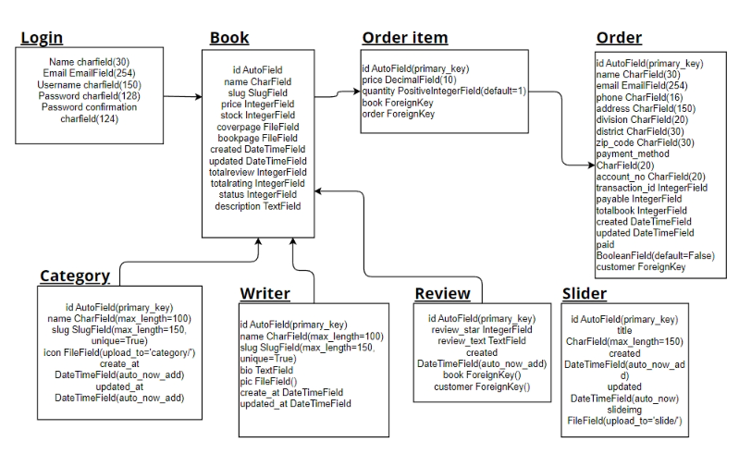

##### TABLE DESIGN

##### **Table No:01**

**Table Name :Login**

**Table Description : To store login information**

|  |  |  |  |
| --- | --- | --- | --- |
| Field Name | Data Type | Constraints | Description |
| Name | CharField | max_length=30,blank=True | Stores name of user |
| Email | EmailField | max_length=254,blank=True | Stores Email of user |
| Username | CharField | max_length=150,blank=True | Stores Username of user |
| Password | CharField | max_length=128 | Stores Password of user |
| Password confirmation | CharField | max_length=128 | Stores Passwordof user for confirmation |

**Table No:02**

**Table Name: book**

**Primary Key: id**

**Table Description: To store book information**

|  |  |  |  |
| --- | --- | --- | --- |
| Field Name | Data Type | Constraints | Description |
| id | Autifield | PK | Uniquely identify the book |
| name | Charfield | Max length=100 | Stores name of book |
| slug | Slugfield | Max length=100 | Stores url friendly version of book name |
| price | Integerfield |  | Stores price of book |
| stock | IntergerField |  | Stores stock of book |
| coverpage | FileField | upload_to=’coverpage/’ | Stores coverpage of book |
| bookpage | FileField | upload_to=’bookpage/’ | Stores bookpage of book |
| created | DataTimeFiled | auto_now_add | Stores date and time of book created |
| updated | DataTimeFiled | auto_now | Stores date and time of book updated |
| total review | IntergerField | Default=1 | Stores total review of book. |
| Total rating | IntergerField | Default=5 | Stores total rating of book. |
| status | IntergerField | Default=0 | Stores status of book. |
| description | TextField |  | Stores description of book. |

**Table No:03**

**Table Name:Category Primary Key:id**

**Table Description: To store course information**

|  |  |  |  |
| --- | --- | --- | --- |
| Field Name | Data Type | Constraints | Description |
| id | AutoField | PK | Uniquely identify the Category |
| name | CharField | max_length=100 | Stores name of Category |
| slug | SlugField | max_length=150,unique=True | Stores URL of category name |
| icon | FileField | upload_to=’category/’ | Stores icon of Category |
| Create_at | DateTimeField | auto_now_add | Stores date and time of category created |
| Updated_at | DateTimeField | auto_now_add | Stores date and time of category updated |

**Table No:04**

**Table Name:review**

**Primary Key :id**

**Table Description: To store review information**

|  |  |  |  |
| --- | --- | --- | --- |
| Field Name | Data Type | Constraints | Description |
| id | AutoField | PK | To uniquely identify review |
| review_star | IntegerField |  | Stores rating given by user |
| review_text | TextField |  | Stores description given by user |
| created | DateTimeField | Auto_now_add | Stores date and time when review created. |
| book | FK | On_delete=models.CASCADE,to=’sore.Book’ | Stores book object associated with review |
| customer | FK | On_delete=models.CASCADE,to=settings.AUTH_USER_MODEL | Stores user object associated with review |

**Table No:05**

**Table Name : slider**

**Primary Key : id**

**Table Description: To store slider information**

|  |  |  |  |
| --- | --- | --- | --- |
| Field Name | Data Type | Constraints | Description |
| id | AutoField | PK | To uniquely identify slider |
| title | CharField | Max_length=150 | Stores title of slider |
| created | DateTimeField | Auto_now_add | Stores date and time of slider created |
| updated | DateTimeField | Auto_now | Stores date and time of slider updated |
| slideimg | FileField | upload_to=’slide/’ | Stores slider image |

**Table No : 06**

**TableName:writer**

**Primary Key : id**

**Table Description: To store writer information**

|  |  |  |  |
| --- | --- | --- | --- |
| Field Name | Data Type | Constraints | Description |
| id | AutoField | PK | To uniquely identify writer |
| name | CharField | Max_length=100 | Stores name of writer |
| slug | SlugField | Max_length=150,  Unique=TRUE | Stores URL of writer name |
| bio | TextField |  | Stores bio of writer |
| pic | FileField | upload_to=’writer/’ | Stores picture of writer |
| Create_at | DateTimeField | Auto_now_add | Stores date and time of slider created |
| Updated_at | DateTimeField | Auto_now | Stores date and time of slider updated |

**Table No:07**

**Table Name :order**

**Primary Key :id**

**Table Description: To store order information**

|  |  |  |  |
| --- | --- | --- | --- |
| Field Name | Data Type | Constraints | Description |
| id | Autifield | PK | Uniquely identify the book |
| name | Charfield | Max length=30 | Stores name of customer |
| email | EmailField | Max length=254 | Stores email of customer |
| phone | Charfield | Max length=16 | Stores phone number of customer |
| city | Charfield | Max length=150 | Stores city of book |
| district | Charfield | Max length=20 | Stores district of customer |
| state | Charfield | Max length=30 | Stores state of customer |
| Zip_code | Charfield | Max length=30 | Stores zip_code of customer |
| Payment_method | Charfield | Max length=20 | Stores payment method of customer |
| Account_no | Charfield | Max length=20 | Stores account number of customer |
| Transaction_id | IntergerField |  | Stores transaction id of customer |
| payable | IntergerField |  | Stores payable amount of customer |
| totalbook | IntergerField |  | Stores totalbook of customer |
| created | DateTimeField | Auto_now_add | Stores date and time of order created |
| updated | DateTimeField | Auto_now | Stores date and time of order created |
| paid | IntergerField | Max length=10 | Stores paid status of customer |

**Table No:08**

**Table Name :order item**

**Primary Key :id**

**Table Description: To store order information**

|  |  |  |  |
| --- | --- | --- | --- |
| Field Name | Data Type | Constraints | Description |
| id | AutoField | Primary_key | Uniquely identify the order item |
| price | DecimalField | decimal_places=2,max_digit=100 | Stores price of book |
| quantity | PositiveIntegerField | Default=1 | Stores quantity of books |
| book | FK | On_delete=models.CASCADE,to=’sore.Book’ | Stores book object associated with order item |
| order | FK | On_delete=models.CASCADE,to=’order.Order’ | Stores order object associated with order item |

**SYSTEM TESTING**

* 1. **INTRODUCTION**

Software testing is the process of carefully controlling the execution of software in order to determine whether it behaves as intended. The words verification and validation are frequently used in conjunction with software testing. Validation is the process of examining or evaluating a product, including software, to determine whether it complies with all relevant specifications. One type of verification, software testing, uses methods including reviews, analyses, inspections, and walk through as well. Verifying that what has been specified matches what the user truly desired is the process of validation.

The processes of static analysis and dynamic analysis are additional ones that are frequently related to software testing. Static analysis examines the software's source code, searching for issues and obtaining statistics without actually running the code. Dynamic analysis examines how software behaves while it is running in order to offer data like execution traces, timing profiles, and test coverage details.

Testing is a collection of activities that can be planned ahead of time and carried out in a methodical manner. Testing starts with individual modules and progresses to the integration of the full computer-based system. There are many rules that can be used as testing objectives, and testing is necessary for the system testing objectives to be successful. As follows:

Testing is a process of executing a program with the intent of finding an error.

* + - A test case with a high likelihood of detecting an unknown fault qualifies as a good test case.
    - A test that finds an error that has not yet been found is successful.

If a test is successfully carried out in accordance with the aforementioned aims, it will reveal software bugs. Additionally, testing shows that the software functions seem to operate in accordance with the specification and that the performance requirements seem to have been satisfied.

There are three ways to test program.

* + - For correctness
    - For implementation efficiency
    - For computational complexity

Testing for correctness is meant to ensure that a programme performs exactly as it was intended to. This is much harder than it might initially seem, especially for big programs.

## TEST PLAN

A test plan suggests a number of desired steps that should be taken in order to complete various testing methods. The action that is to be taken is outlined in the test plan. A computer programme, its documentation, and associated data structures are all created by software engineers. It is always the responsibility of the software developers to test each of the program's individual components to make sure it fulfils the purpose for which it was intended. In order to solve the inherent issues with allowing the builder evaluate what they have developed, there is an independent test group (ITG). Testing's precise goals should be laid forth in quantifiable language. so that the cost to discover and remedy the problem, the mean time to failure. The test plan should include information on the cost to find and fix the defects, the remaining defect density or frequency of occurrence, and the number of test work hours required for each regression test.

The levels of testing include:

* + Unit testing
  + Integration Testing
  + Widget Testing

##### Unit Testing

Unit testing concentrates verification efforts on the software component or module, which is the smallest unit of software design. The component level design description is used as a guide when testing crucial control paths to find faults inside the module's perimeter. the level of test complexity and the untested area determined for unit testing. Unit testing is white-box focused, and multiple components may be tested simultaneously. To ensure that data enters and exits the programme unit under test properly, the modular interface is tested. To make sure that data temporarily stored retains its integrity during each step of an algorithm's execution, the local data structure is inspected. To make sure that each statement in a module has been executed, boundary conditions are evaluated.

Before starting any other test, tests of data flow across a module interface are necessary. All other tests are irrelevant if data cannot enter and exit the system properly. An important duty during the unit test is the selective examination of execution pathways. Error conditions must be foreseen in good design, and error handling paths must be set up to cleanly reroute or terminate processing when an error does occur. The final step of unit testing is boundary testing. Software frequently fails at its limits.

In the Sell-Soft System, unit testing was carried out by treating each module as a distinct entity and subjecting them to a variety of test inputs. The internal logic of the modules had some issues, which were fixed. Each module is tested and run separately after coding. All unused code was eliminated, and it was confirmed that every module was functional and produced the desired outcome.

##### Integration Testing

Integration testing is a methodical approach for creating the program's structure while also carrying out tests to find interface errors. The goal is to construct a programme structure that has been determined by design using unit tested components. The programme as a whole is tested. Correction is challenging because the size of the entire programme makes it challenging to isolate the causes. As soon as these mistakes are fixed, new ones arise, and the process repeats itself in an apparently unending cycle. All of the modules were integrated after unit testing was completed in the system to check for any interface inconsistencies. A distinctive programme structure also developed when discrepancies in programme structures were eliminated.

##### Widget Testing

In other UI frameworks, a widget test—also referred to as a component test—evaluates a single widget. Confirming that a widget's user interface (UI) performs and behaves as intended is the goal of a widget test. Testing widgets entails testing several classes in a test environment that provides the right widget lifecycle context.

For instance, the widget being evaluated should be able to execute layout, accept user events and actions, and respond to them, as well as generate child widgets. A widget test is therefore more in-depth than a unit test. Similar to a unit test, a widget test replaces the environment with a much simpler implementation rather than a full-fledged UI system.

##### SeleniumTesting

Selenium is an open-source tool that automates web browsers. It provides a single interface that lets you write test scripts in programming languages like Ruby, Java, NodeJS, PHP, Perl, Python, and C#, among others. The Selenium testing tool is used to automate tests across browsers for web applications. It's used to ensure high-quality web applications—whether they are responsive, progressive, or regular. Selenium is an open-source tool.

# CONCLUSION & FUTURE SCOPE

## 6.1 CONCLUSION

In conclusion, the Online Bookstore System developed in Django provides a convenient and efficient way for customers to purchase books online, and for the bookstore to manage their inventory and sales. The system offers many advantages over traditional offline bookstores, including wider reach, lower overhead costs, easier inventory management, 24/7 availability, wider selection, and improved marketing capabilities..

## 6. 2 FUTURE SCOPE

* Mobile application
* Social media integration
* Personalized recommendations
* Collaboration with publishers
* Integration with e-book formats
* Expansion to other countries
* Audio book integration
* Virtual book clubs

# BIBLIOGRAPHY

##### REFERENCES:

* Gary B. Shelly, Harry J. Rosenblatt, “*System Analysis and Design*”, 2009.
* Roger S Pressman, “*Software Engineering*”, 1994.
* PankajJalote, “So*ftware engineering*: a precise approach”, 2006.
* James lee and Brent ware Addison, “Open source web development with LAMP”, 2003
* IEEE Std 1016 Recommended Practice for Software Design Descriptions.

##### WEBSITES:

* [www.w3schools.com](http://www.w3schools.com/)
* [www.jquery.com](http://www.jquery.com/)
* [https://www.lovelycoding.org/ezylearn/](https://www.lovelycoding.org/construction-work-management-system/)
* https://app.diagrams.net
* <http://homepages.dcc.ufmg.br/~rodolfo/es-1-03/IEEE-Std-830-1998.pdf>
* [www.agilemodeling.com/artifacts/useCaseDiagram.html](http://www.agilemodeling.com/artifacts/useCaseDiagram.html)

# APPENDIX

## 8.1 Screen Shots

#### Login Page

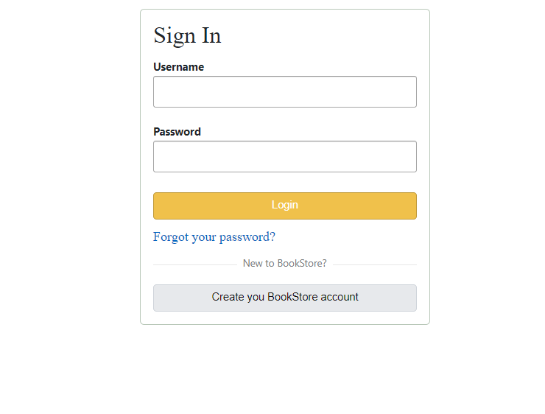

**Home Page (Hod/Admin)**



**Writer Page**



**Book Page**

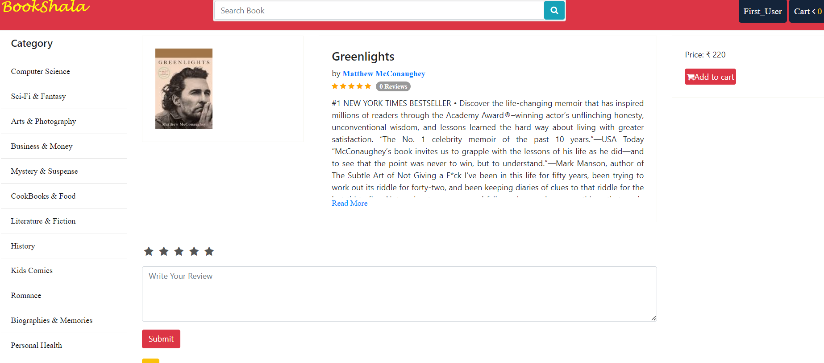

**Cart Page**

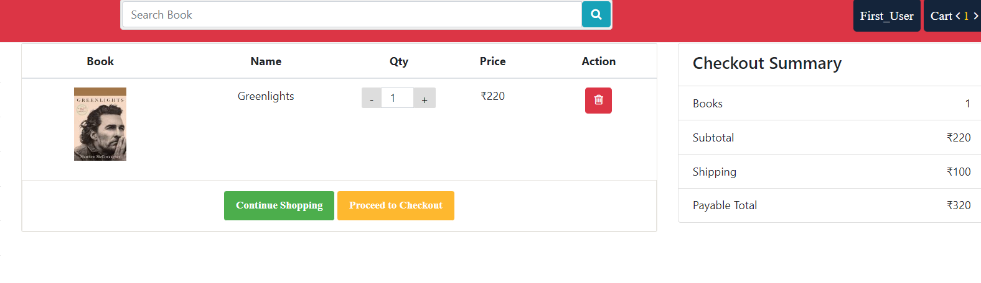

**Checkout Page**

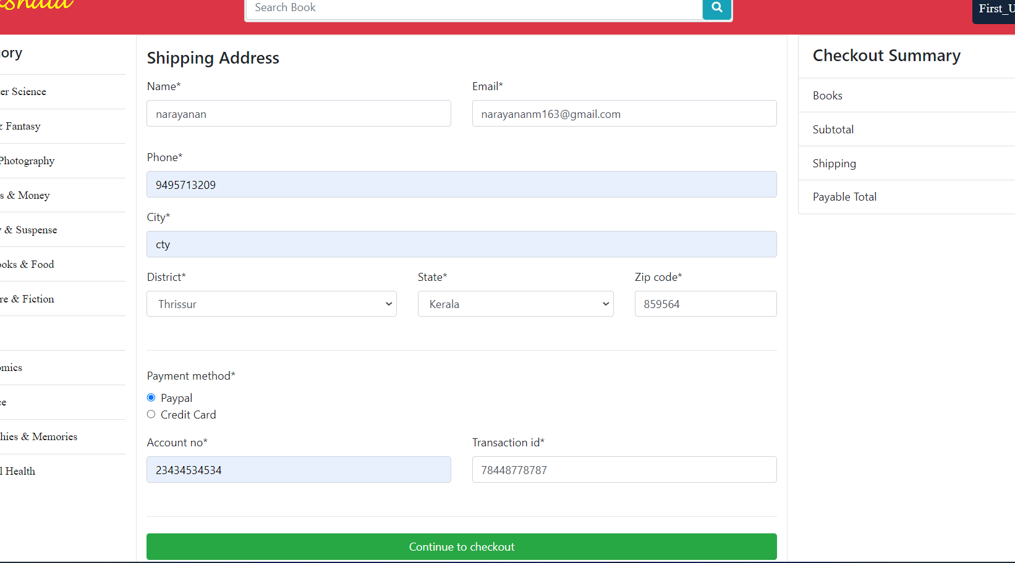

**Invoice**

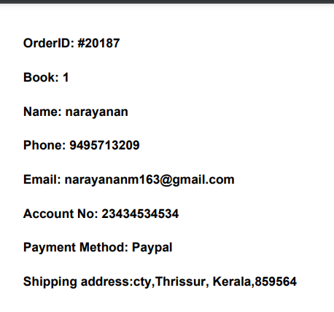

**Admin**

